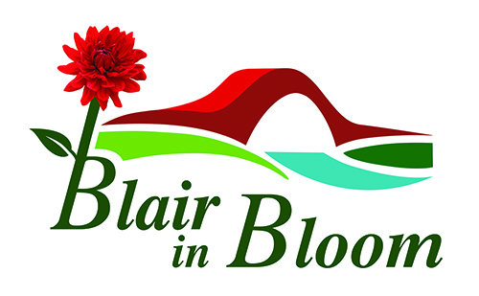

Annual Report 2021

January 2021 started pretty much the same as 2020 ended – another lockdown! With snow & the ground frozen, there was not much we could do outside anyway. However, as usual work was going on behind the scenes planning for the rest of the year. Plug plants were ordered, in the hope that we could put up our hanging baskets once again. We took the decision not to charge businesses in 2021, as our contribution to the recovery of the town.

Sadly, shortly after our last AGM we learned of the death of our Honorary President Sir William Macpherson. He supported us for many years and took a great interest in our plans.

The bulb planting that was done in Autumn of 2020 gave a colourful show for Spring 2021 with the Elm Drive crocuses, the tete-a-tete daffodils at the Golf Course Road corner, white crocuses marking the Snow Road at Westfields carpark and the first year of the crocuses opposite Tesco highlighting Motor Neuron Disease.

We were finally able to get out in social distanced pairs in March, so lots of tidying up done all around the town. It was great to be out and about again.

The sale of the Mount Ericht site finally went through towards the end of March – a collective sigh of relief by all concerned. A lot of hard work has been done since then and clearing the site has been challenging. We were able to plant a crop of potatoes in May with the help of Bob Smith and his trusty tractor and provide free potatoes to the BARI Foodstore and also to Little’s Restaurant, along with having some ourselves! We continue to work closely with BRDT on fund raising for Rattray Community Garden, as it is now known.

The hanging baskets and remaining refurbished street containers were set out early in June and gave a colourful display throughout the summer. Everyone was pleased to see the baskets out again – even if the Christmas lights were still in situ! Hopefully that will not be the case this year.

Fortunately we were able to go ahead with some much needed fund raising in 2021 and held two pop-up shops in May and October and our annual plant sale in June.

The Meeting Place had a much-needed facelift in September, carried out by the Community Payback Team. I think everyone agrees it looks much better. We have plans to replace the gravelled surface this year, funding permitting.

We had two large successful funding applications - £10,000 to the Community Investment Fund and £10,000 to the Lintel Trust. The CIF fund was partly for Rattray Community Garden and partly to purchase a vehicle to enable us to carry out our own watering. We now have an ATV which William Wilson & John McLean sourced. This will be invaluable, not just for watering the baskets but for moving compost, tools etc around the various sites in the town.
The remaining monies go towards the installation of utilities at Rattray Community Garden.
Planting for Spring 2022 was done in October/November, with a blue yellow/gold scheme to highlight the 75th anniversary of Blairgowrie& Rattray Rotary Club, who are such great supporters of Bloom. Many more bulbs were planted along Elm Drive, opposite Tesco, at Rattray Cross and Rattray Common.
The group were treated to lunch at Little’s Restaurant at the end of October, courtesy of the generosity of Willie Little, which everyone appreciated.
Due to Storm Arwen, our Quiz Night in November was postponed, but is going ahead on 18 February 2022.
We were able to hold a Christmas Hamper raffle in Tesco for the first time for 2 years, which once again brought in much need funds.

We finished the year planting bowls of paper-white narcissi for the Saturday Lunch Club recipients, which were well received on Christmas morning.

I would like to finish by thanking everyone who has supported us this year, we are truly grateful for your generosity, support and enthusiasm. We have a great group of volunteers who turn out – mostly in all weathers – and just get on with the task of making the town look good and my thanks go to all of them.

Finally, I have to thank the Bloom Committee who do so much to support each other and me in realising our goals. It has been a challenging couple of years and I am proud beyond measure of all that has been achieved during this difficult time.

Lots of exciting times ahead in 2022, so watch this space!

